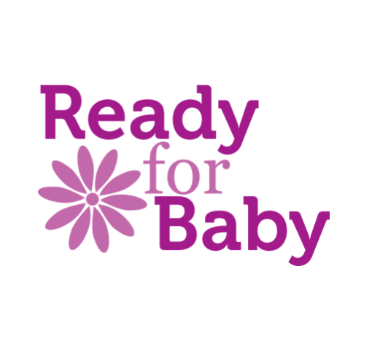
Terms and Conditions and Cancellation Policy for Mother & Baby Yoga / Baby Massage Sessions Run by Caroline Graham ( Ready for Baby)

- At all times during the session the mother, parent or guardian is responsible for their own baby/infant.

- Participation in a session is subject to completion of a registration form disclosing any relevant medical or health information.

- Participants are expected to adhere to the NHS and government guidance and self-isolate (do not attend the session) if showing they fulfil any of the criteria set out here: https://www.nhs.uk/conditions/coronavirus-covid-19/self-isolation-and-treatment/when-to-self-isolate-and-what-to-do/
In the event of a participant missing a session due to self- isolating an online session will be offered as an alternative.

- Any discounts or vouchers must be presented before or at the time of payment for the discounts to be applied.

- Session fees to be paid within one week of booking or it will be assumed your place is cancelled unless we are notified.

- If a course/one-to-one session is booked and subsequently cancelled in writing or by email by the client, refunds will be supplied as follows:

42+ calendar days before the workshop begins: 75% refund
32-41 calendar days: 50%
22-31 calendar days: 25%
21 calendar days or less or “no show”: 0%

In the event of personal tragedy, requests for a refund will be considered on an individual basis. An administration charge may be made.

- In the event of a lockdown due to a pandemic the sessions will be continued online.

- In the rare event of your Practitioner being taken ill or being otherwise unable to run your course either alternative dates will be offered, or a replacement Practitioner will be found, or you will receive a full refund. We shall endeavour to work with you to find the best solution.

