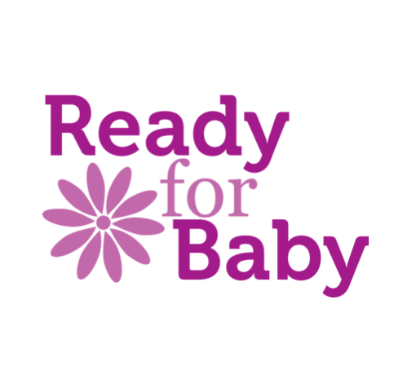
COVID-19 risk assessment for Mum & Baby Yoga / Baby Massage run by Caroline Graham (Ready for Baby)

Company name: Ready for Baby
Assessment carried out by: Caroline Graham
Date assessment was carried out: 5/9/2020
What are the hazards? | Who might be harmed and how? | Controls | What further action do you need to consider to control the risks?
Getting or spreading coronavirus in common use high traffic areas such as the cafe, corridors, rest rooms, toilet facilities, entry/exit points to facilities, | Instructor  Clients  Gym staff/ members | Clients advised to stay home if feeling unwell, contact details taken for contact tracing. Details passed to venue.  Temperature taken on entry to venue  All to sanitise hands on entry to the venue  D10 available for sanitising floor if required  Venue fogged every 30 days  Follow guidance of maximum number of clients in the space with socially distanced spaces marked out.  Air conditioning on during session.  Doors propped open to avoid touching door handles  Accessible toilet accommodates one person at a time | Provide the following information by email and verbally:  Clients advised to stay home if feeling unwell, contact details taken for contact tracing.  Clients advised to social distance in the venue and to stay in their allotted space.  Clients to bring their own equipment (mat and towel) if gym equipment is used it will be sanitised before and after use. Handouts to be emailed rather than given out.  Meet clients on entry and guide them to the room ensuring social distancing.
Getting or spreading coronavirus by not washing hands or not washing them adequately | Instructor  Clients  Gym staff/ members | All to sanitise hands on entry to the venue  Provide water, soap and drying facilities at toilets  Hand sanitiser available in the studio | Remind clients on booking information and during the session of expectations.

