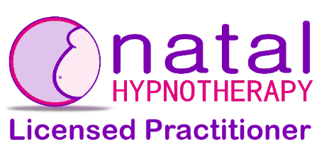

Terms and Conditions and Cancellation Policy for Natal HypnotherapyTM Workshops Run by Ready for Baby

The following terms and conditions are produced in accordance with guidance published by Natal HypnotherapyTM.

A one-day Natal HypnotherapyTM workshop costs £99 for a pregnant woman and her birth partner.

A one-day workshop provided on a requested one-to-one basis costs £165 for a pregnant woman and her birth partner. Travel up to 10 miles from the practitioner’s home is included. If the journey from the Practitioner’s home to the client’s home is over 10 miles the Practitioner reserves the right to charge 45p per mile for the additional mileage. An alternative venue may be agreed between the Practitioner and the Clients.

Any discounts or vouchers must be presented at the time of booking for the discounts to be applied.

Workshop fees should be paid in full at time of booking please.

If a workshop/one-to-one workshop is booked and subsequently cancelled in writing or by email by the client, refunds will be supplied as follows:

42+ calendar days before the workshop begins: 75% refund
32-41 calendar days: 50%
22-31 calendar days: 25%
21 calendar days or less or “no show”: 0%

In the event of a premature birth or personal tragedy, requests for a refund will be considered on an individual basis. An administration charge may be made.

Details of workshop venue will be published near the date of the workshop and chosen based on the appropriateness of the venue for the number of client bookings.

In the rare event of your Practitioner being taken ill or being otherwise unable to run your workshop either alternative dates will be offered, or a replacement Practitioner will be found, or you will receive a full refund. We shall endeavour to work with you to find the best solution.

