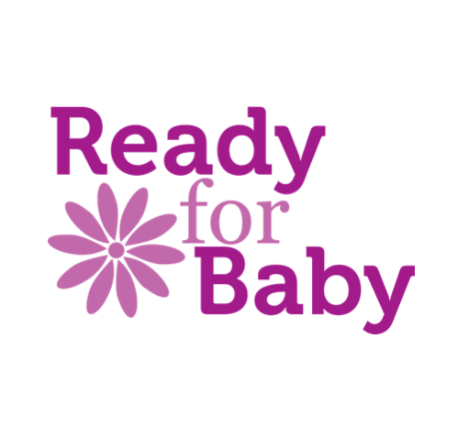

Terms and Conditions and Cancellation Policy for Baby Massage Sessions Run by Ready for Baby

Any discounts or vouchers must be presented at the time of booking for the discounts to be applied.

Session fees should be paid in full at time of booking please.

If a course/one-to-one session is booked and subsequently cancelled in writing or by email by the client, refunds will be supplied as follows:

42+ calendar days before the workshop begins: 75% refund
32-41 calendar days: 50%
22-31 calendar days: 25%
21 calendar days or less or “no show”: 0%

In the event of personal tragedy, requests for a refund will be considered on an individual basis. An administration charge may be made.

Details of workshop venue will be published near the date of the workshop and chosen based on the appropriateness of the venue for the number of client bookings.

In the rare event of your Practitioner being taken ill or being otherwise unable to run your course either alternative dates will be offered, or a replacement Practitioner will be found, or you will receive a full refund. We shall endeavour to work with you to find the best solution.

