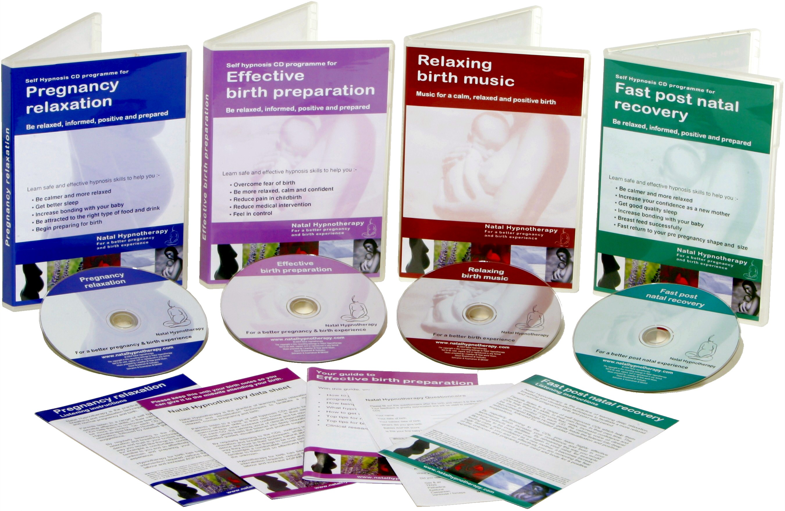
Natal Hypnotherapy™ Fact sheet

What is Natal Hypnotherapy™?
Natal Hypnotherapy™ prepares women emotionally, physically and mentally for conception, pregnancy and birth. Women learn a combination of self hypnosis techniques, deep relaxation and guided visualization to help them overcome fears, create a state of calm and relaxation, be more confident and so have a calmer, more relaxed pregnancy and birth. The method was developed by UK Clinical Hypnotherapist Maggie Howell in 2000 and has helped tens of thousands of women in the UK.

Is Natal Hypnotherapy™ recognised by the medical profession?
Yes, over 2300 midwives and birth professionals across the UK are now recommending Natal hypnotherapy techniques. In addition hypnotherapy is an accepted therapeutic practice, having been recognised by the British Medical Association since 1955.

What do women have to do to learn the techniques?
Women learn Natal Hypnotherapy™ techniques simply by listening to a series of relaxing CDs in the privacy of their own home. A soothing voice guides them into a calm state, teaching breathing and relaxation, followed by positive suggestions designed to increase the listeners trust and confidence. The comprehensive range of CDs are available from preparing to conceive through to support with breastfeeding.

Are more in depth courses available?
Yes – Natal Hypnotherapy™ run antenatal birth preparation courses across the UK. The intensive 2 day courses are run by fully qualified and insured Natal Hypnotherapy™ practitioners. All courses are monitored and regulated to ensure a consistently high standard of tuition. The courses teach more in depth self hypnosis skills plus a wide range of practical and informative tools and techniques to help both mother and her birth partner feel more confident and prepared for birth.

How much does it cost?
The CDs retail at £16 each or £50 for the 4 CD set programme. Courses are between £180 and £280 dependant on location around the UK.

Is this the same as HypnoBirthing?
No, Natal Hypnotherapy™ is not the same as HypnoBirthing® which was developed in the US by Marie Mongon. Natal Hypnotherapy™ has been developed in the UK by its founder, Clinical Hypnotherapist, Maggie Howell. Natal Hypnotherapy™ has been developed organically through her experiences of using them for her own four births as well as those of women she has supported in her work as a Doula and through her work with leading birth specialists including Michael Odent, Ina May Gaskin and Sheila Kitzinger. The style, techniques and tools differ considerably from the US Hypnobirthing approach

Has Natal Hypnotherapy™ won any awards?
Yes – it was awarded the “Practical Parenting - Pregnancy product of the year” and the “Practical parenting Editors awards”

Do women recommend Natal Hypnotherapy™?
Based on a survey of 768 mums who responded to a post natal questionnaire, 98% would recommend the CDs as an essential part of their pregnancy kit.

Now can you find out more?
For information on Natal Hypnotherapy™, research, hundreds of testimonials and birth stories or to book on a course or buy a CD please go to www.natalhypnotherapy.co.uk or call Tel 01428 712615. CDs can also be bought from many retailers including the NCT and Amazon as well as directly from

